Dear Parents and Carers,

On Thursday 17th October, 2024, Woodlands will be holding our first family event of the year.

We would like to invite parents, carers, children and family members to attend a Bingo night!
There will be a range of prizes to win on the day and all money raised will go towards the trips and experiences we can offer the children.

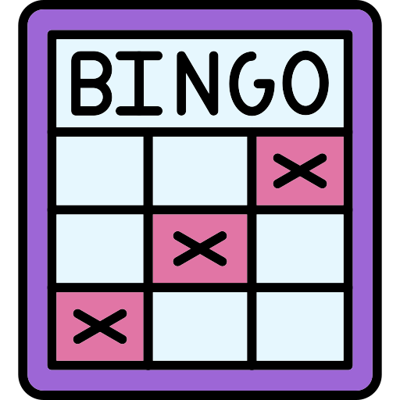
What time? 3:30 - 4:30 pm
Where? The school hall

Please return the form below if you are interested in joining us.

Yours sincerely.
Mrs Clark and Team Woodlands

__________________________________________________________________________________
Family Bingo Night!
Thursday 17th October
3:30 - 4:30pm in the hall
I _____________ (parent/carer) would like _________________ (number of seats) for the bingo night.

