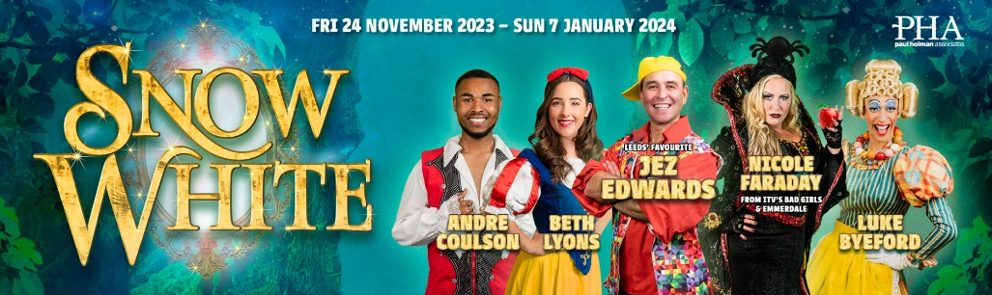
20th November 2023
Dear Parents/Carers,
Reception & Year 6 Visit to the Pantomime
On Tuesday 12th December the children in Reception and Year 6 are going on a trip to the Carriageworks Theatre in Leeds to see their Snow White pantomime.
The children will be travelling from school by coach. We will depart school at approximately 9:15. Please ensure that your child is at school on time, on the day. The children will arrive back at school, to be collected at the normal time of 3:15pm.
Your child will need to wear uniform on the day. Please make sure that your child is wearing the appropriate clothing for the weather, including a warm, waterproof coat and waterproof shoes. The pastoral team are working on a school uniform exchange. If you have any worries regarding the financial cost for the uniform requirements outlined in this letter, please contact our pastoral team.
The classes will return to school after the pantomime for lunch at approximately 12:30. Because this is slightly later than their normal lunch time, the children will have packed lunches in their classroom. Children who receive free school meals will be provided with a packed lunch. If you wish, your child may bring their own lunch and water to drink.
We are asking for a donation of £1.00 to help cover the transport and ticket costs.
We are looking forward to visiting the Carriageworks Theatre and we hope that your child is too.
If you would like to join us on the trip, please inform your child’s class teacher.
Yours Sincerely

Miss Wilson
English Lead
___________________________________________________________________________
Reception and Year 6 – Trip to the Carriageworks Theatre
Child’s name: _________________________________
I enclose a donation of £1.00.
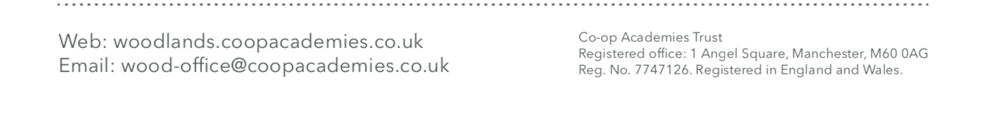
My child will require a school packed lunch.

